Q7)

In Cisco Packet Tracer, create a small network with multiple devices (e.g., 2 PCs and a router).
Use private IP addresses (e.g., 192.168.1.x) on the PCs and configure the router to perform NAT to
allow the PCs to access the internet.

Task: Test the NAT configuration by pinging an external IP address from the PCs and capture the
traffic using Wireshark.

What is the source IP address before and after NAT?
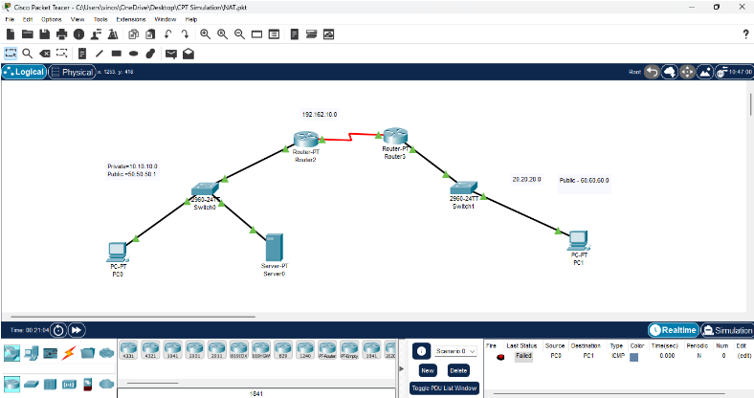
•

Before NAT: The PC uses 192.168.1.10, which is a private IP, and cannot be routed
on the internet.

• After NAT: The router translates this private IP to its public IP (203.0.113.1) before
forwarding the packet to the destination.

• Return Traffic: When the reply comes from 8.8.8.8, the router reverses the NAT
translation and sends the packet back to 192.168.1.10.

• NAT Overload (PAT) ensures multiple internal devices can share the same public IP
by tracking sessions using port numbers.

